For 1(b) we use following codes.

clc;

clear all;

%%

%init parameters

p0 = 0.001;

X_all_all = {};

P_all_all = {};

for scale = 1:1:4

p0 = p0*10;

Q = 0;

R = 0.1*eye(3);

X_0 =[3;3];

D = diag([0.1,0.1,0.1]);

X_all = zeros(2,51);

X_all(:,1) = X_0;

A = eye(2);

L1 = [0;0];

L2 = [5;5];

L3 = [2.5;0];

P_true = [0.7212; 2.4080];

P_0_0 = p0*eye(2);

%%

%iternation parameters

P_all = zeros(2,2,51);

P_all(:,:,1) = P_0_0;

y = zeros(3,51);

l_y = zeros(3,51);

%%

%kalman filter

for k = 1:1:50

w_k = normrnd(0,1,[3,1]);

x_k_k = X_all(:,k);

x_k1_k = A*x_k_k;

y_k1 = [2.5;

5;

3]+D*w_k;

y(:,k) = y_k1;

P_k_k = P_all(:,:,k);

P_k1_k = A*P_k_k*A'+Q;

C_k1 = linerity(x_k1_k,L1,L2,L3);

Kk = P_k1_k*C_k1'/(C_k1*P_k1_k*(C_k1')+R);

P_k1_k1 = P_k1_k-Kk*C_k1*P_k1_k;

l_y(:,k) = measure(x_k1_k,L1,L2,L3);

x_k1_k1 = x_k1_k+Kk*(y_k1-l_y(:,k));

P_all(:,:,k+1) = P_k1_k1;

X_all(:,k+1) = x_k1_k1;

end

X_all_all{end+1} = X_all;

P_all_all{end+1} = P_all;

end

figure(1)

hold on

for i = 1:1:length(X_all_all)

X_all = X_all_all{i};

plot(X_all(1,:),X_all(2,:));

end

plot(P_true(1),P_true(2),'ro');

legend("p0=0.01","p0=0.1","p0=1","p0=10","true place of P");

title("trajectory of x");

hold off

figure(2)

p_norm = zeros(4,51);

tt = 0:1:50;

for j = 1:1:length(P_all_all)

P_all = P_all_all{j};

for i=1:51

p_norm(j,i) = norm(P_all(:,:,i),'fro');

end

end

semilogy(tt,p_norm(1,:));

hold all

semilogy(tt,p_norm(2,:));

semilogy(tt,p_norm(3,:));

semilogy(tt,p_norm(4,:));

legend("p0=0.01","p0=0.1","p0=1","p0=10");

title("frobenius norm of Pk|k versus k");

grid on

%%

%linerity function for EKF

function C_k1 = linerity(xk,L1,L2,L3)

C_k1 = [(xk-L1)'/norm(xk-L1);

(xk-L2)'/norm(xk-L2);

(xk-L3)'/norm(xk-L3)];

end

function g_x = measure(xk,L1,L2,L3)

g_x = [norm(xk-L1);

norm(xk-L2);

norm(xk-L3)];

end

And the pictures look like below:

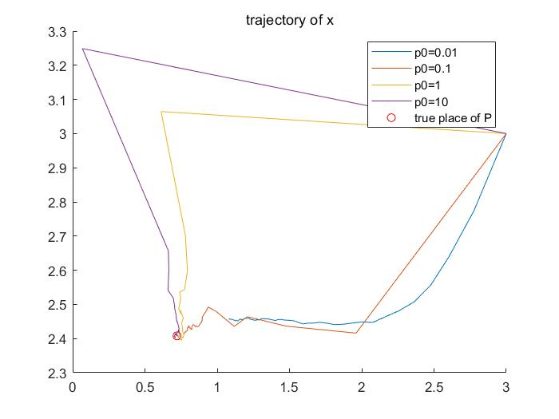

P1: trajectory of x

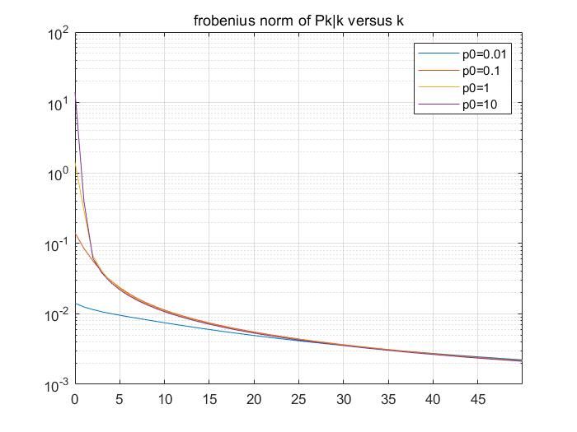

P2: forbenius norm of Pk|k versus k

For 2(a) we use following codes.

clc;

clear all;

load("rcwA.mat");

%plot3(rcwA_Ts_0_01(1,:),rcwA_Ts_0_01(2,:),rcwA_Ts_0_01(3,:));

T = 0.01;

A = [eye(3), T*eye(3);

zeros(3,3), eye(3)];

B = [T^2/2*eye(3);

T*eye(3)];

g = 9.80665;

D1 = diag([0.1, 0.1 0.1]);

D2 = diag([0.1, 0.1 0.1]);

phi = pi/6;

O_ba_0 = [1,0,0;

0, cos(phi), sin(phi);

0, -sin(phi), cos(phi)];

r_0 = [1,0,0]';

v_0 = [0, cos(phi), sin(phi)]';

O_k_all = zeros(3,3,2001);

O_k_all(:,:,1) = O_ba_0;

x_k_all = zeros(6,2001);

x_k_all(:,1) = [r_0;v_0];

for k = 1:1:2000

w_k = [0,0,1]'+D1*normrnd(0,1,[3,1]);

a_k = [-1-g*sin(phi)*sin(k*T);

-g*sin(phi)*cos(k*T);

-g*cos(phi)]+D2*normrnd(0,1,[3,1]);

O_k1 = expm(-T*vec_to_mat(w_k)) *O_k_all(:,:,k);

O_k_all(:,:,k+1)=O_k1;

x_k = x_k_all(:,k);

x_k1 = A*x_k+B*(O_k1'*a_k-[0,0,-g]');

x_k_all(:,k+1)=x_k1;

end

figure(1)

hold on

plot3(rcwA_Ts_0_01(1,:),rcwA_Ts_0_01(2,:),rcwA_Ts_0_01(3,:));

plot3(x_k_all(1,:),x_k_all(2,:),x_k_all(3,:));

hold off

legend("reference trajectory","estimated trajectory");

function matrix = vec_to_mat(w)

wx = w(1);

wy = w(2);

wz = w(3);

matrix = [0,-wz,wy;wz,0,-wx;-wy,wx,0];

end

And the picture look like below:

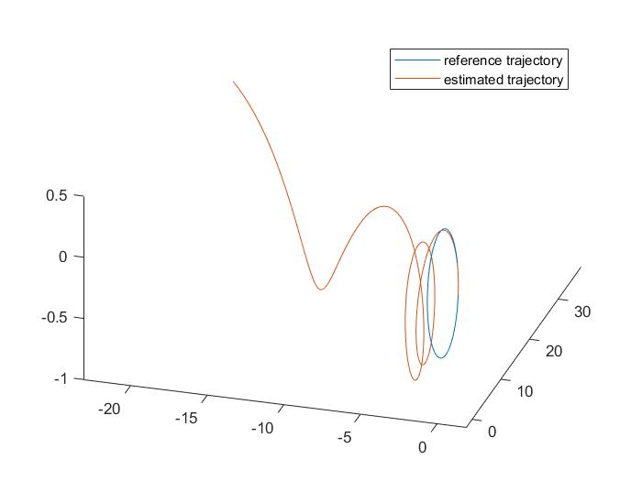

P3: trajectory with only gyro and accelerometer measurements

For 2(b) we use following codes.

clc;

clear all;

load("rcwA.mat");

T = 0.01;

A = [eye(3), T*eye(3);

zeros(3,3), eye(3)];

B = [T^2/2*eye(3);

T*eye(3)];

g = 9.80665;

D1 = diag([0.1, 0.1 0.1]);

D2 = diag([0.1, 0.1 0.1]);

D3 = diag([0.005, 0.005, 0.005]);

phi = pi/6;

O_ba_0 = [1,0,0;

0, cos(phi), sin(phi);

0, -sin(phi), cos(phi)];

r_0 = [1,0,0]';

v_0 = [0, cos(phi), sin(phi)]';

O_k_all = zeros(3,3,2001);

O_k_all(:,:,1) = O_ba_0;

R = 0.001*eye(3);

Q = 10*eye(6);

P_all = zeros(6,6,2001);

P_all(:,:,1) = 10*eye(6);

x_k_all = zeros(6,2001);

x_k_all(:,1) = [r_0;v_0];

C = [eye(3), zeros(3,3)];

Tmocap = 1;

y_k1 = rcwA_Ts_0_01(:,1);

for k = 1:1:2000

if(mod((k+1)*T,Tmocap)==0)

Ck1=C;

y_k1 = rcwA_Ts_0_01(:,k+1)+D3*normrnd(0,1,[3,1]);

else

Ck1 = zeros(3,6);

end

w_k = [0,0,1]'+D1*normrnd(0,1,[3,1]);

a_k = [-1-g*sin(phi)*sin(k*T);

-g*sin(phi)*cos(k*T);

-g*cos(phi)]+D2*normrnd(0,1,[3,1]);

O_k1 = expm(-T*vec_to_mat(w_k)) *O_k_all(:,:,k);

O_k_all(:,:,k+1)=O_k1;

x_k_k = x_k_all(:,k);

x_k1_k = A*x_k_k+B*(O_k1'*a_k-[0,0,-g]');

Pkk = P_all(:,:,k);

P_k1_k = A*Pkk*A'+Q;

Kk = P_k1_k*Ck1'*inv(Ck1*P_k1_k*Ck1'+R);

P_k1_k1 = P_k1_k-Kk*Ck1*P_k1_k;

x_k1_k1 = x_k1_k+Kk*(y_k1-Ck1*x_k1_k);

x_k_all(:,k+1)=x_k1_k1;

end

x_t_1 = x_k_all;

Tmocap = 0.1;

y_k1 = rcwA_Ts_0_01(:,1);

for k = 1:1:2000

if(mod((k+1)*T,Tmocap)==0)

Ck1=C;

y_k1 = rcwA_Ts_0_01(:,k+1)+D3*normrnd(0,1,[3,1]);

else

Ck1 = zeros(3,6);

end

w_k = [0,0,1]'+D1*normrnd(0,1,[3,1]);

a_k = [-1-g*sin(phi)*sin(k*T);

-g*sin(phi)*cos(k*T);

-g*cos(phi)]+D2*normrnd(0,1,[3,1]);

O_k1 = expm(-T*vec_to_mat(w_k)) *O_k_all(:,:,k);

O_k_all(:,:,k+1)=O_k1;

x_k_k = x_k_all(:,k);

x_k1_k = A*x_k_k+B*(O_k1'*a_k-[0,0,-g]');

Pkk = P_all(:,:,k);

P_k1_k = A*Pkk*A'+Q;

Kk = P_k1_k*Ck1'*inv(Ck1*P_k1_k*Ck1'+R);

P_k1_k1 = P_k1_k-Kk*Ck1*P_k1_k;

x_k1_k1 = x_k1_k+Kk*(y_k1-Ck1*x_k1_k);

x_k_all(:,k+1)=x_k1_k1;

end

figure(1)

hold on

plot3(rcwA_Ts_0_01(1,:),rcwA_Ts_0_01(2,:),rcwA_Ts_0_01(3,:));

plot3(x_t_1(1,:),x_t_1(2,:),x_t_1(3,:),'g');

plot3(x_k_all(1,:),x_k_all(2,:),x_k_all(3,:),'r');

hold off

axis equal;

xlabel("x");

ylabel("y");

zlabel("z");

legend("reference trajectory","T_{mocap}=1 estimated trajectory","T_{mocap}=0.1 estimated trajectory");

figure(2)

for i=1:1:3

subplot(3,1,i)

hold on

plot(0:0.01:20,rcwA_Ts_0_01(i,:));

plot(0:0.01:20,x_t_1(i,:),'g');

plot(0:0.01:20,x_k_all(i,:),'r');

hold off

legend("reference","T_{mocap}=1","T_{mocap}=0.1");

if(i==1)

st = "trajectory versus time x-axis";

elseif(i==2)

st = "trajectory versus time y-axis";

else

st = "trajectory versus time z-axis";

end

title(st);

xlabel("time(s)");

end

function matrix = vec_to_mat(w)

wx = w(1);

wy = w(2);

wz = w(3);

matrix = [0,-wz,wy;wz,0,-wx;-wy,wx,0];

end

And the pictures look like below:

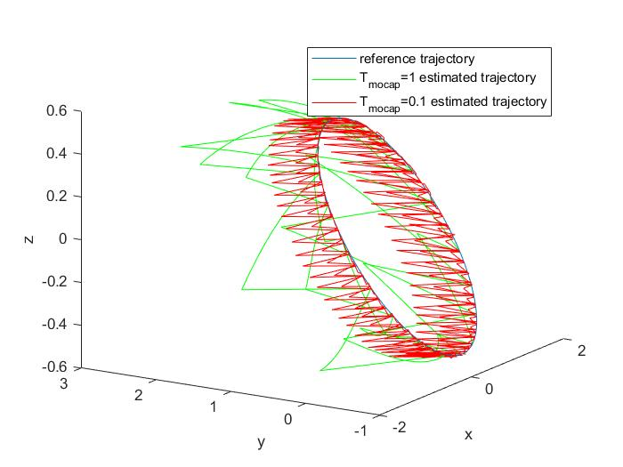

P4: trajectories with measurements at different frequencies

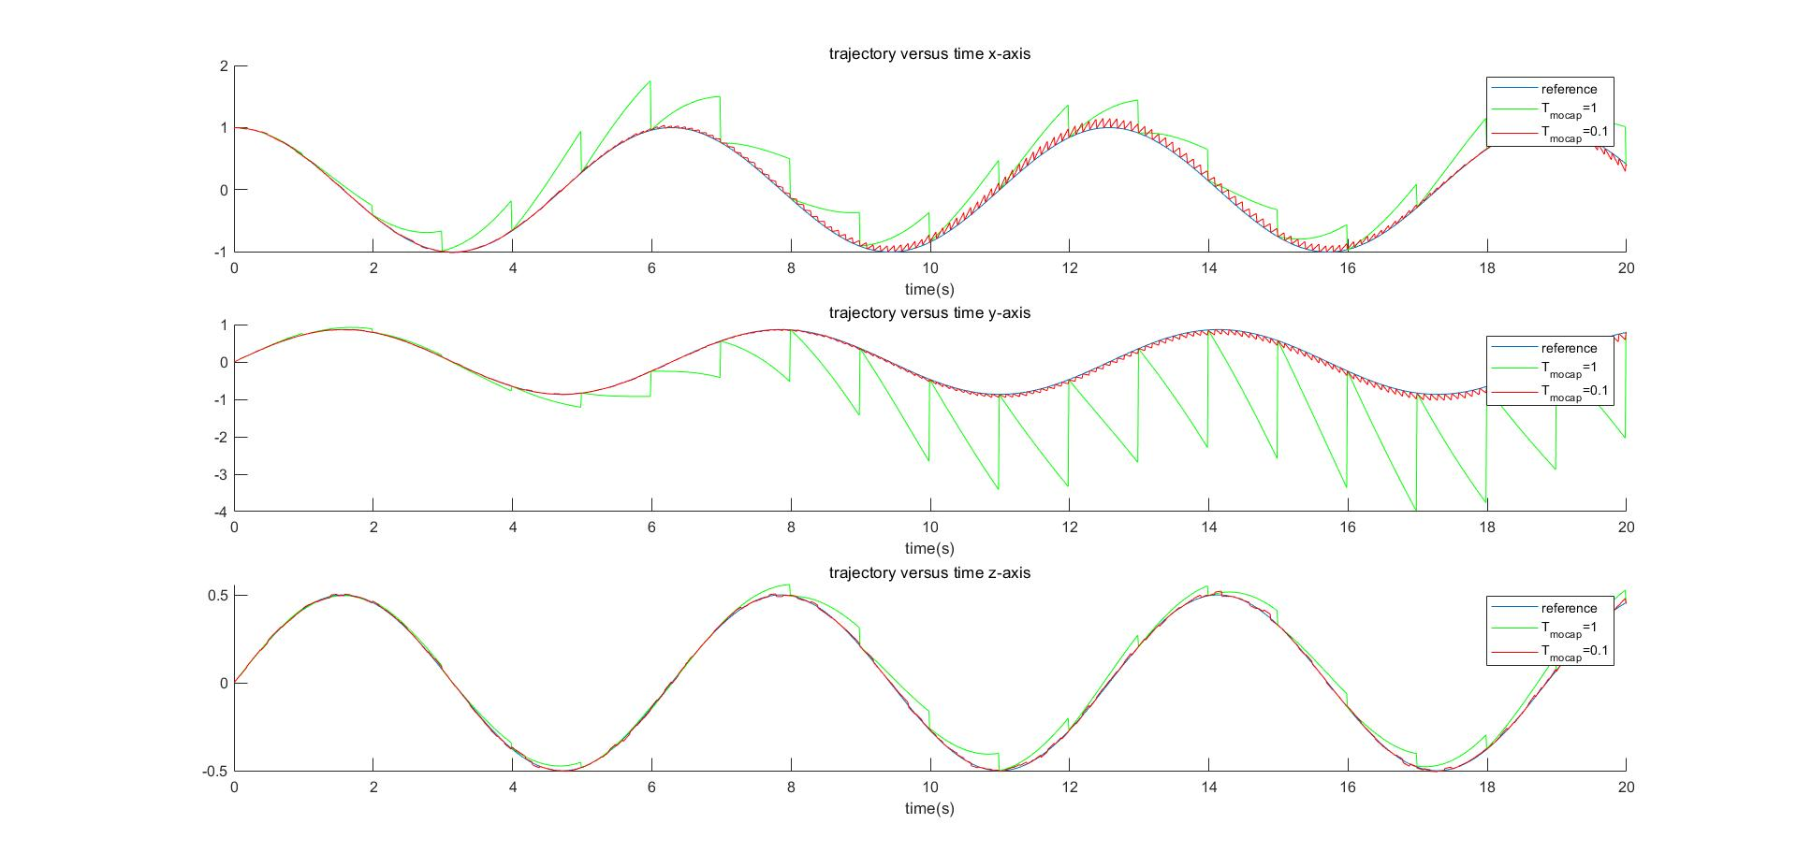

P4: trajectories on different axis